Anne – Q1 & Q5
Kathleen – Q2
Steffen – Q3
Tony – Q4

Question 1. (Anne)
- How would you describe a condition in which one attribute is dependent on another attribute when neither attribute is part of the primary key?

Transitive Dependency.

b) Why is a table whose primary key consists of a single attribute automatically in
2NF when it is in 1NF?

2NF is only necessary if the primary key is a composite key.

Question 2 (Kathleen)
Attribute Name | Sample Value | Sample Value | Sample Value
STU_NUM | 211343 | 200128 | 199876
STU_LNAME | Stephanos | Smith | Jones
STU_MAJOR | Accounting | Accounting | Marketing
DEPT_CODE | ACCT | ACCT | MKTG
DEPT_NAME | Accounting | Accounting | Marketing
DEPT_PHONE | 4356 | 4356 | 4378
COLLEGE_NAME | Business Admin | Business Admin | Business Admin
ADVISOR_LNAME | Grastrand | Grastrand | Gentry
ADVISOR_OFFICE | T201 | T201 | T228
ADVISOR_BLDG | Torre Building | Torre Building | Torre Building
ADVISOR_PHONE | 2115 | 2115 | 2123
STU_GPA | 3.87 | 2.78 | 2.31
STU_HOURS | 75 | 45 | 117
STU_CLASS | Junior | Sophomore | Senior

- Show this group of attributes in 1NF. (Kathleen)

1NF: (STU_NUM, COLLEGE_ID, DEPT_ID, STU_LNAME, STU_MAJOR, STU_GPA, STU_HOURS, STU_CLASS, ADVISOR_LNAME, ADVISOR_OFFICE, ADVISOR_BLDG, ADVISOR_PHONE, COLLEGE_NAME, DEPT_CODE, DEPT_NAME, DEPT_PHONE)

- Write the dependency diagram to show this set of attributes in 2NF and 3NF. Label the partial and transitive dependencies on the diagram. (Kathleen)

2NF: (No partial dependencies)

Table name: Student

STU_ NUM | STU_ LNAME | STU_ GPA | STU_ HOURS | STU_ CLASS | ADVISOR_ LNAME | ADVISOR_ OFFICE | ADVISOR_ BLDG | ADVISOR_ PHONE

Transitive dependencies

Table name: College

COLLEGE_ID | COLLEGE_NAME

Table name: Department

DEPT_ID | DEPT_CODE | DEPT_NAME | DEPT_PHONE | STU_ MAJOR
Transitive dependency

3NF: (No transitive dependencies)

Table name: Student

STU_ NUM | STU_ LNAME | STU_ GPA | STU_ HOURS | STU_ CLASS

Table name: College

COLLEGE_ID | COLLEGE_NAME

Table name: Department

DEPT_ID | DEPT_CODE | DEPT_NAME | DEPT_PHONE

Table name: Advisor

ADVISOR_ID | ADVISOR_LNAME | ADVISOR_OFFICE | ADVISOR_BLDG | ADVISOR_PHONE

Table name: Major

DEPT_ID | STU_MAJOR

- Draw the ERD for this. Show cardinality. (Kathleen)

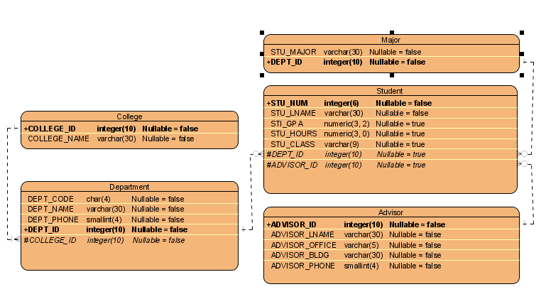

Question 3 (Steffen)
Attribute Name | Sample Value | Sample Value | Sample Value
ITEM_ID | 231134-678 | 342245-225 | 254668-449
ITEM_LABEL | HP DeskJet 895Cse | HP Toner | DT Scanner
ROOM_NUMBER | 325 | 325 | 123
BLDG_CODE | NTC | NTC | CSF
BLDG_NAME | Nottooclear | Nottoclear | Canseefar
BLDG_MANAGER | I. B. Rightonit | I. B. Rightonit | May B. Next

- Show this group of attributes in 1NF. (Steffen)

Item (ITEM_ID, ITEM_LABEL)
Building (ROOM_NUMBER, ITEM_ID, BLDG_CODE, BLDG_NAME, BLDG_MANAGER)

- Write the dependency diagram to show this set of attributes in 2NF and 3NF. Label the partial and transitive dependencies on the diagram. (Steffen)

2NF (No Partial Dependencies)

Items:
ITEM_ID | ITEM_LABEL

Buildings:
BLDG_CODE | BLDG_NAME | BLDG_MANAGER
Transitive

Item
Locations:
ITEM_ID | ROOM_NUMBER | BLDG_CODE

3NF (No Transitive Dependencies)

Items:
ITEM_ID | ITEM_LABEL

Buildings:
BLDG_CODE | BLDG_NAME | MANAGER_ID

Item
Locations:
ITEM_ID | ROOM_NUMBER | BLDG_CODE

Managers:
MANAGER_ID | MANAGER_NAME

- Draw the ERD for this. Show cardinality. (Steffen)

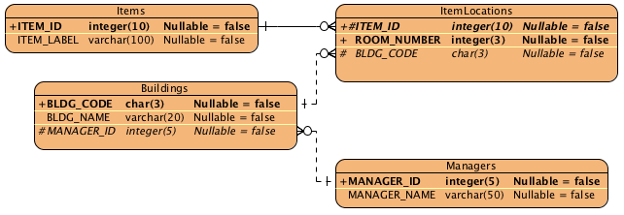

Question 4
Attribute Name | Sample Value | Sample Value | Sample Value | Sample Value
EMP_NUM | 1003 | 1018 | 1019 | 1023
EMP_LNAME | Willaker | Smith | McGuire | McGuire
EMP_EDUCATION | BBA, MBA | BBA |  | BS, MS, Ph.D.
JOB_CLASS | SLS | SLS | JNT | DBA
EMP_DEPENDENTS | Gerald (spouse),  Mary (daughter),  John (son) |  | JoAnne (spouse) | George (spouse)  Jill (daughter)
DEPT_CODE | MKTG | MKTG | SVC | INFS
DEPT_NAME | Marketing | Marketing | General Service | Info. Systems
DEPT_MANAGER | Jill H. Martin | Jill H. Martin | Hank B. Jones | Carlos G. Ortez
EMP_TITLE | Sales Agent | Sales Agent | Janitor | DB Admin
EMP_DOB | 23-Dec-1968 | 28-Mar-1979 | 18-May-1982 | 20-Jul-1959
EMP_HIRE_DATE | 14-Oct-1997 | 15-Jan-2006 | 21-Apr-2003 | 15-Jul-1999
EMP_TRAINING | L1, L2 |  | L1 | L1, L3, L8, L15
EMP_BASE_SALARY | $38,255.00 | $30,500.00 | $19.750.00 | $127,900.00
EMP_COMMISSION_RATE | 0.015 | 0.010

- Show this group of attributes in 1NF.
- Write the dependency diagram to show this set of attributes in 2NF and 3NF. Label the partial and transitive dependencies on the diagram.
- Draw the ERD for this. Show cardinality.

Question 5 (Anne)
Attribute Name | Sample Value | Sample Value | Sample Value
MEMBER_NUM | 214 | 235 | 214
MEMBER_NAME | Alice B. VanderVoort | Gerald M. Gallega | Alice B. VanderVoort
MEMBER_ADDRESS | 325 Meadow Park | 123 Rose Court | 325 Meadow Park
MEMBER_CITY | Murkywater | Highlight | Murkywater
MEMBER_ZIPCODE | 12345 | 12349 | 12345
INVITE_NUM | 8 | 9 | 10
INVITE_DATE | 23-Feb-2006 | 12-Mar-2006 | 23-Feb-2006
ACCEPT_DATE | 27-Feb-2006 | 15-Mar-2006 | 27-Feb-2006
DINNER_DATE | 15-Mar-2006 | 17-Mar-3006 | 15-Mar-2006
DINNER_ATTENDED | Yes | Yes | No
DINNER_CODE | DI5 | DI5 | DI2
DINNER_DESCRIPTION | Glowing Sea Delight | Glowing Sea Delight | Ranch Superb
ENTREE_CODE | EN3 | EN3 | EN5
ENTREE_DESCRIPTION | Stuffed crab | Stuffed crab | Marinated steak
DESERT_CODE | DE8 | DE5 | DE2
DESERT_DESCRIPTION | Chocolate mousse  with raspberry sauce | Cherries Jubilee | Apple pie with honey  crust
- Show this group of attributes in 1NF.

1Nf ( Member_num, Invite_num, Member_name, member_address, member_city, member_zipcode. Member_num, invite_date, accept_date, dinner_date, dinner_attended, dinner_code, dinner_description, entrée_code, entrée_description, desert_code, desert_description) (Anne)

- Write the dependency diagram to show this set of attributes in 2NF and 3NF. Label the partial and transitive dependencies on the diagram.

2NF (no partial dependencies) (Anne)

Member_info
( Member_num, Member_name, member_address, member_city, member_zipcode)

Invite_details
( Invite_num, Member_num, invite_date, accept_date, dinner_date, dinner_attended, dinner_code, dinner_description, entrée_code, entrée_description, desert_code, desert_description)

Member_info

MEM_NUM | Mem_name | MEM_  ADD | MEM_  CITY | Mem_  zip

Invite_details

INV_  NUM | Mem_  num | Inv_  date | Acc_  date | Din_  date | Din_att | Din_  code | Din_  desc | Ent_  code | Ent_  desc | Des_  code | Des_  desc

Transitive dependencies

3NF (no transitive dependencies) (Anne)

Member_name
( Member_num, Member_name)

Member_Details
(Member_num, member_city, member_zipcode, member_address)

Invite_details
( Invite_num, Member_num, invite_date, accept_date, dinner_date, dinner_attended, dinner_code, entrée_code, desert_code)

Dinner_details
( Dinner_code, dinner_description)

entrée_details
( entrée_code, entrée_description)

desert_details
( desert_code, desert_description)

Member_info

MEM_NUM | MEM_  NAME

MEM_NUM | MEM_ADD | MEM_  CITY | Mem_  zip

Invite_details

INV_  NUM | Mem_  num | Inv_  date | Acc_  date | Din_  date | Din_att | Din_  code | Ent_  code | Des_  code

Dinner_details

Din_  code | Din_  desc

Entree_details

ENT_  code | Ent_  desc

Dessert_details

Des_  code | des_  desc

- Draw the ERD for this. Show cardinality.

